**HTTP -Application**

**Visual Studio** -> open the HTTPApplication project

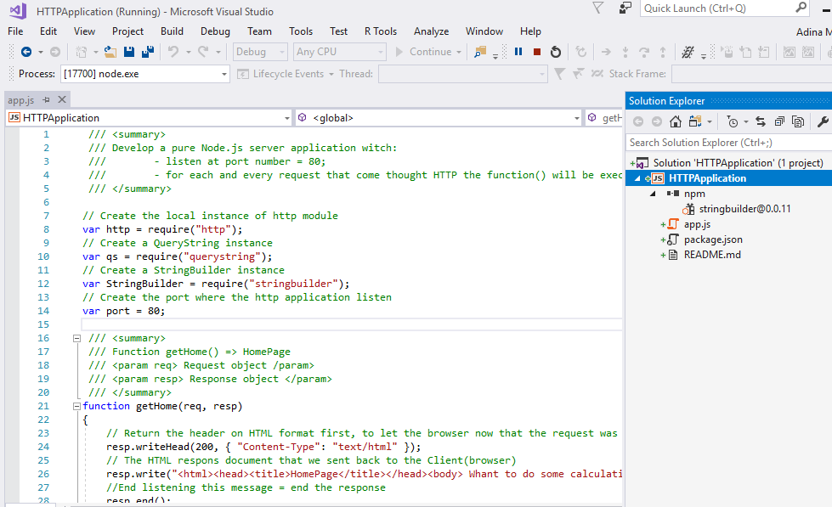

**Prerequisites:**

-install the **stringbuilder** package

-use **http** (module build in)

-use **querystring** (module querystring build in)

**Code sourse:**

My GitHub profile: <https://github.com/adsoftmar>

**How to test the HTTP Application**

**Step 1:** Visual Studio -> Open HTTPApplication project

And **run**

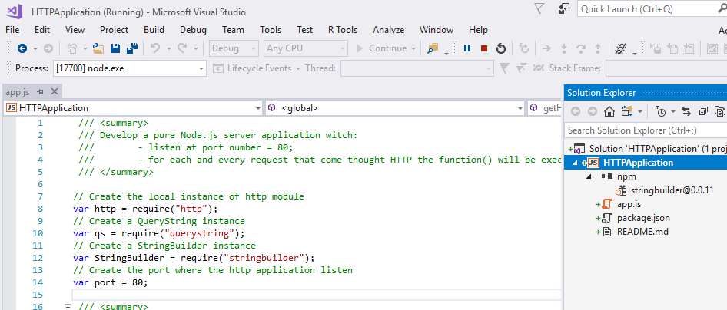

**Step 2:** Open in parallel some browsers: Explorer, Firefox, Chrome (and others if you have installed)

and go to localhost: <http://localhost:80>

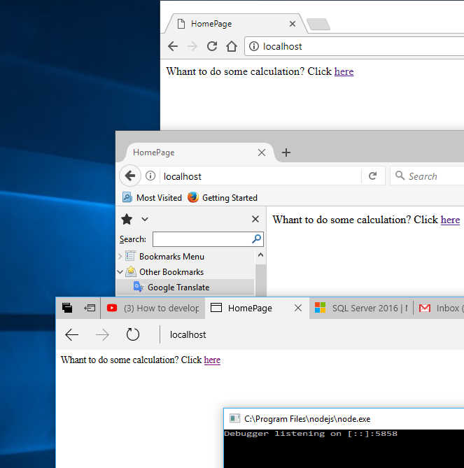

**Step 3:** Click on **here**

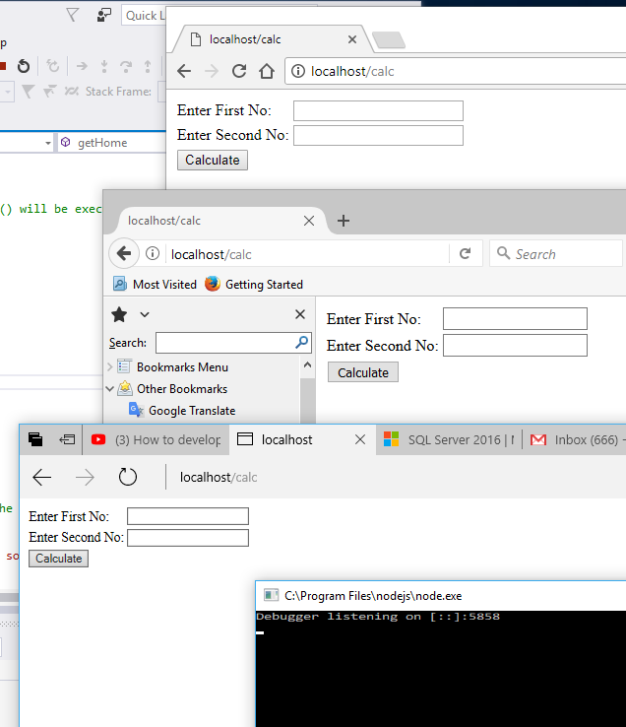

**Step 4:** For simplicity choose one browser: I choose Chrome and open the **Development Tool**

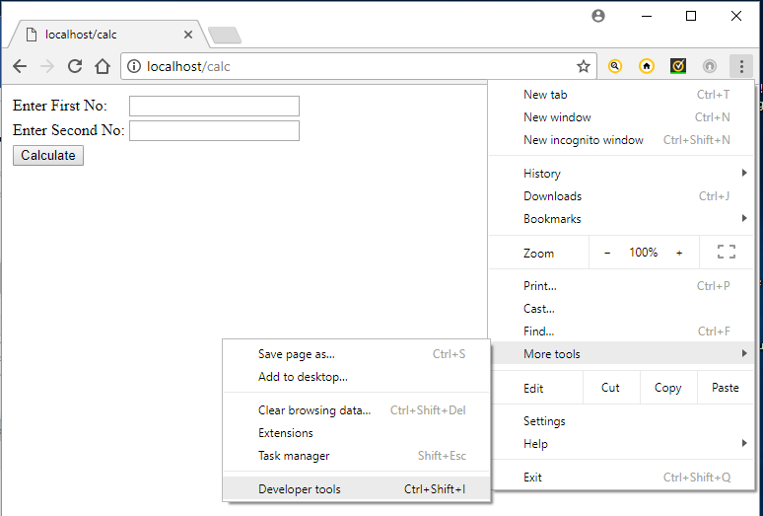

**Step 5:**Add some numbers and create different scenarios to cover all the situation (sending error, correct) and analyze the results

